AWS DAY 5 AND 6 ASSIGNMENT
PROJECT 1:
Working with IAM Roles with S3 and bootstrapping with EC2
Task1: Creating a bootstrapped instance
SS1: Edit user data
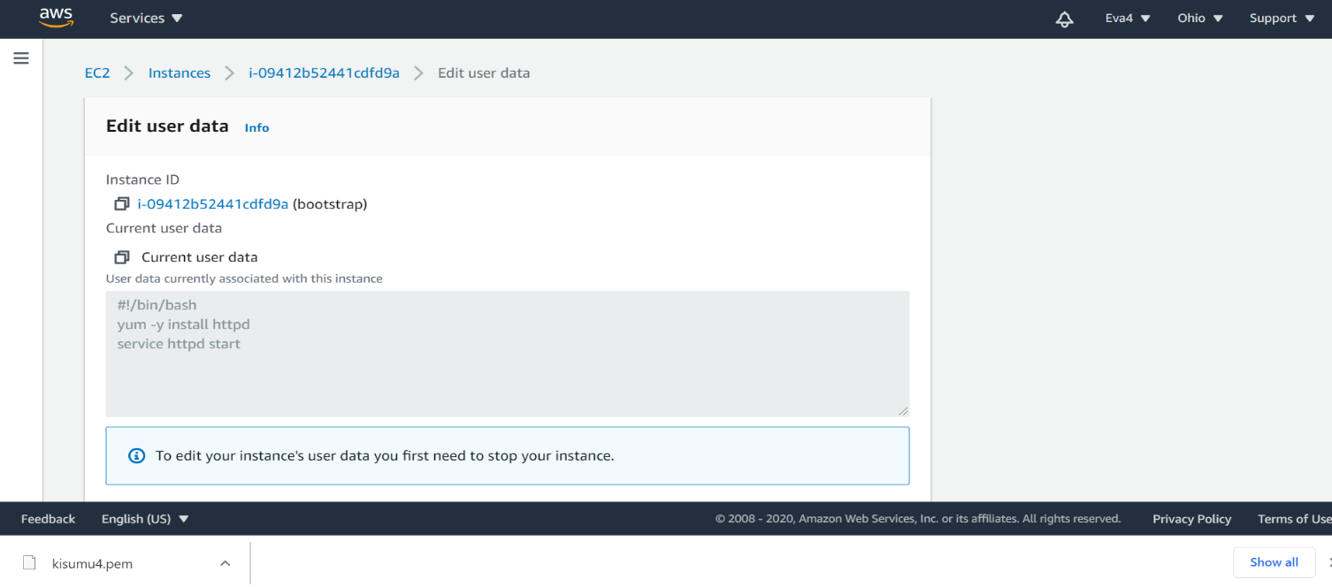

SS2: List of ec2 instances with description

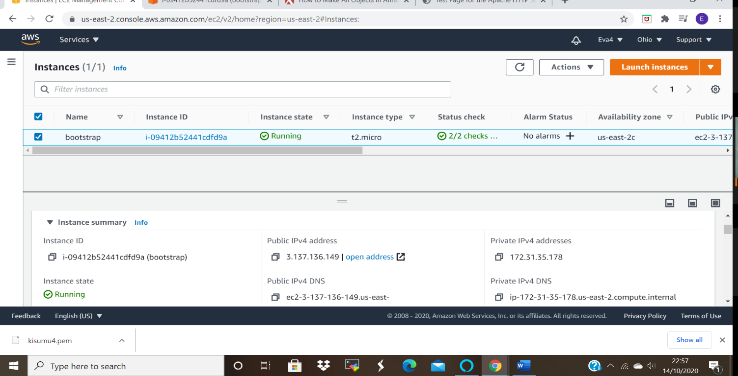

SS3: Test page
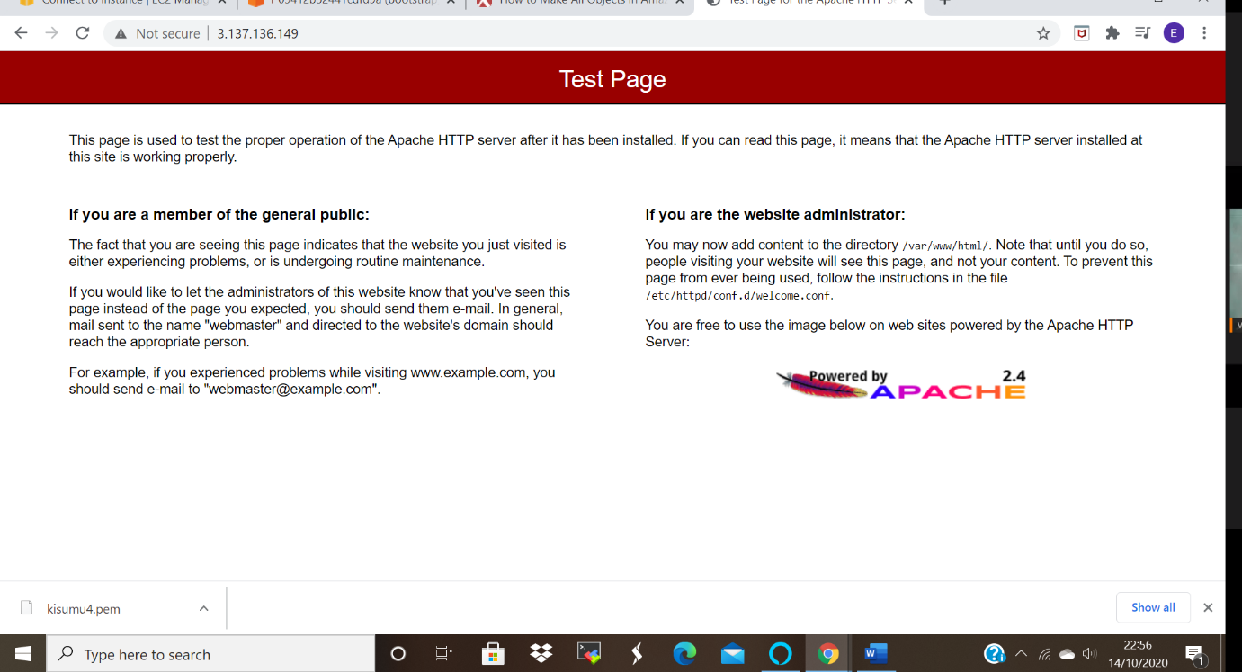

Task 2 : Checking bucket list and creating a new bucket from EC2 using IAM Roles
Ss1: User data
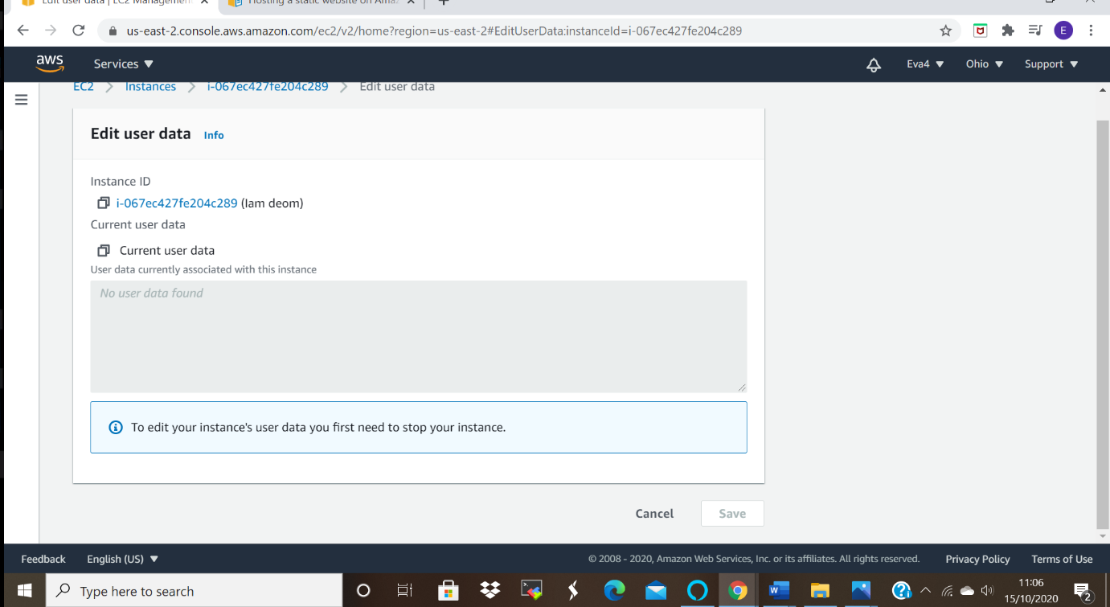

Ss2: List of ec2 instances with description
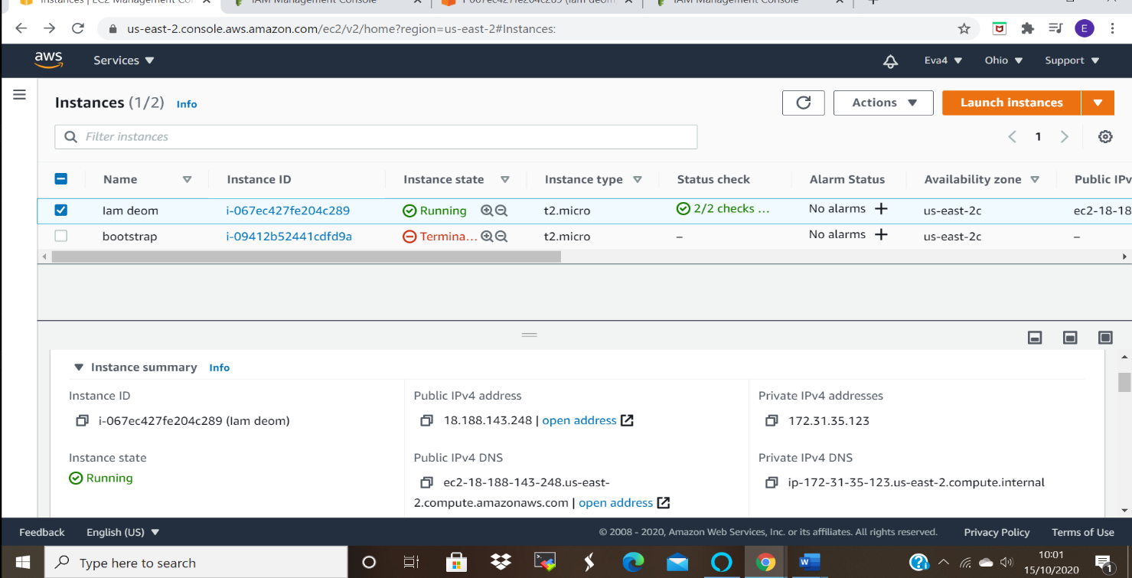

Ss3: 3 Commands to be executed and outputs displayed
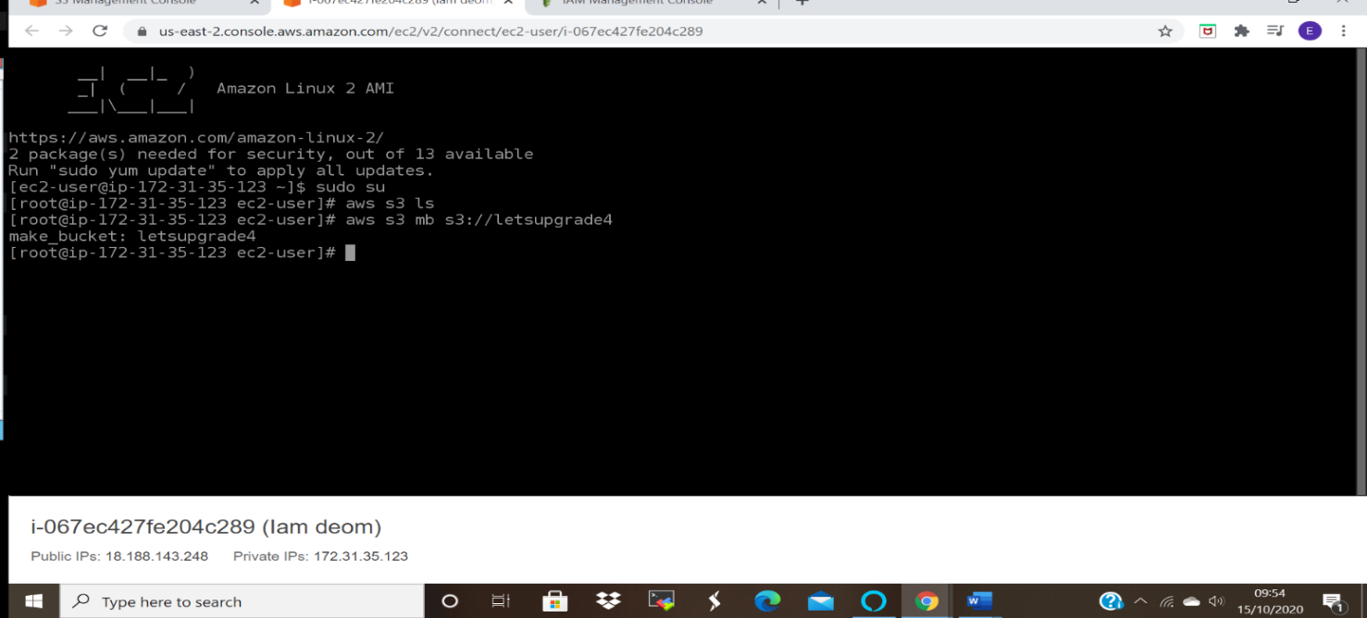

Task 3:Hosting a webpage using the bootstrap script on ec2.
Ss1: User data
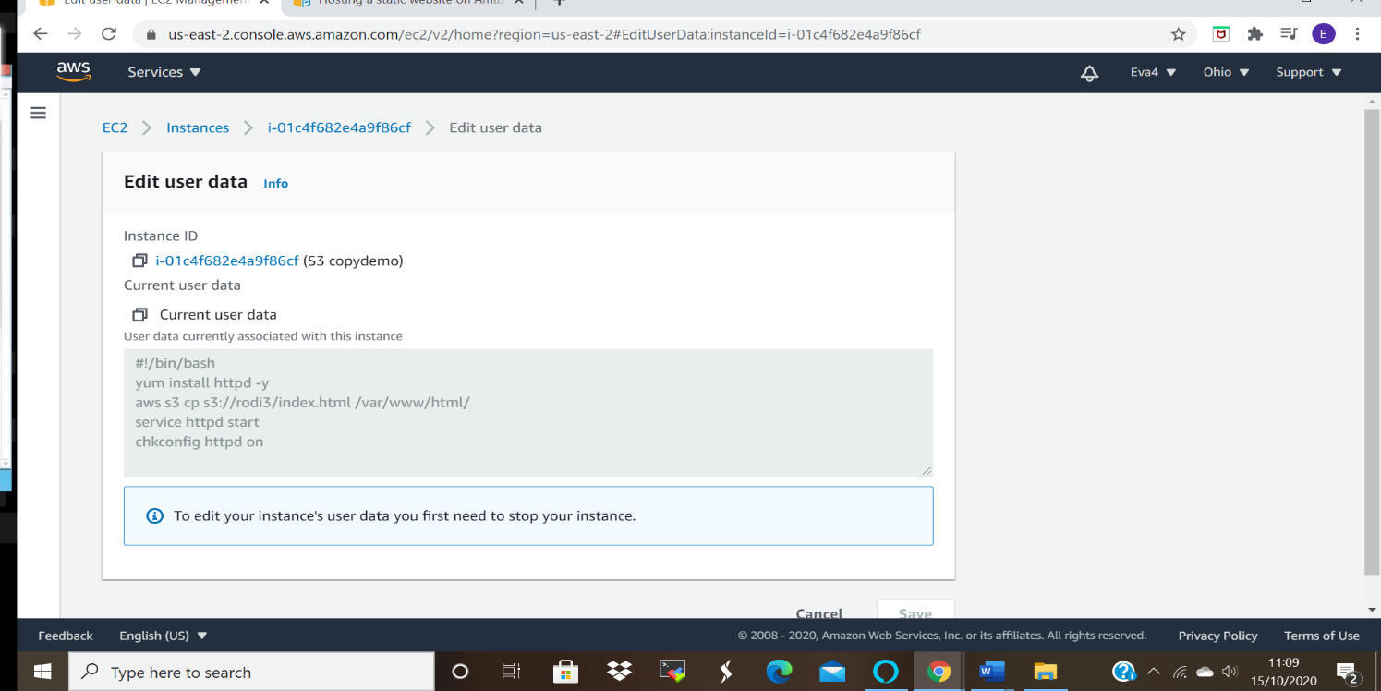

Ss2: S3 Bucket,index.html
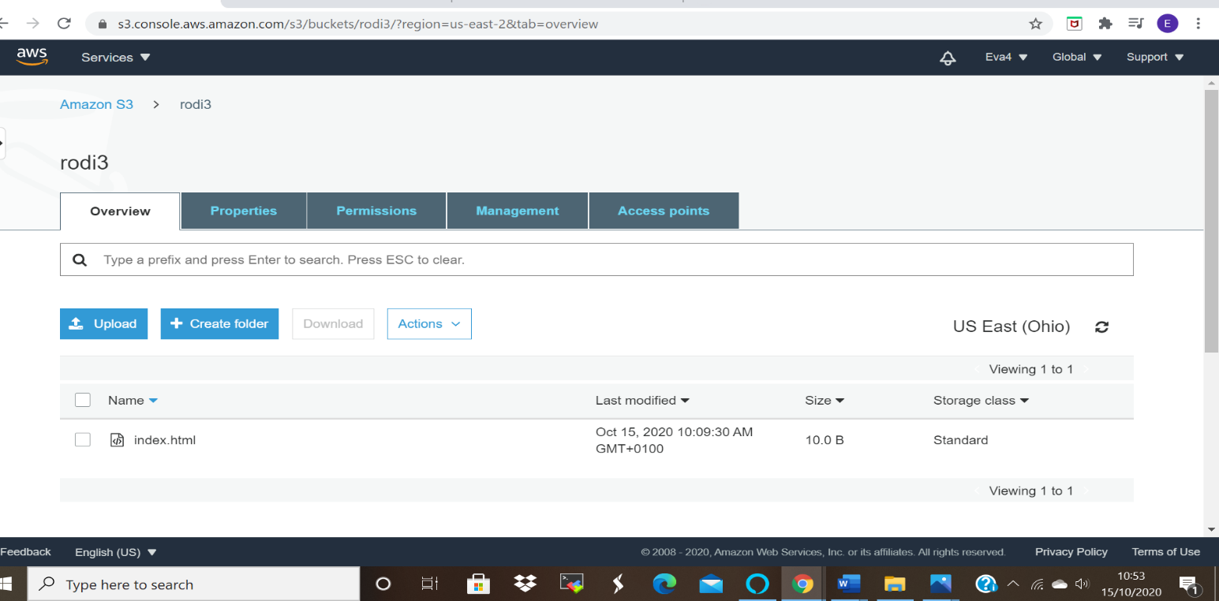

Ss3: Testing using public IP:
I am not sure why why was not able to access the index.html web page, I tried to go through it again but it came up with the test page.
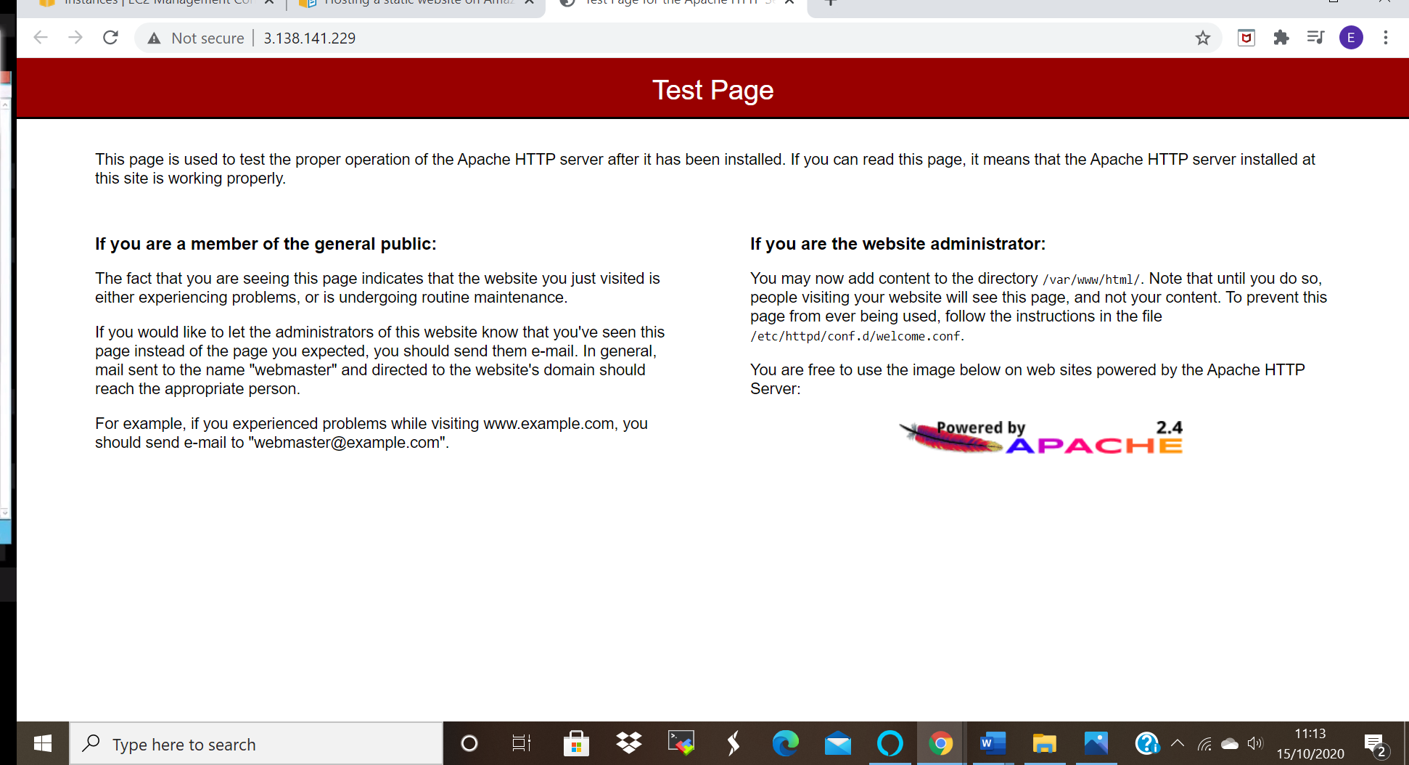

PROJECT 2:
Creating an EC2 instance in custom VPC
Task1: Create a VPC
Ss1: VPC created
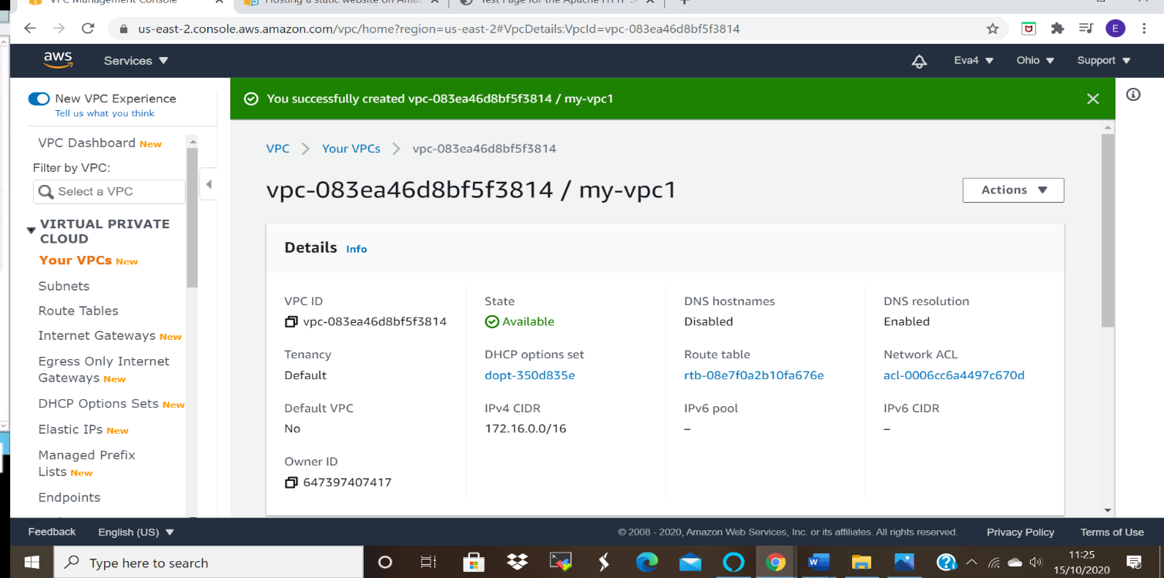

Task 2: Create an Internet gateway
Ss2:IGW with VPC associated
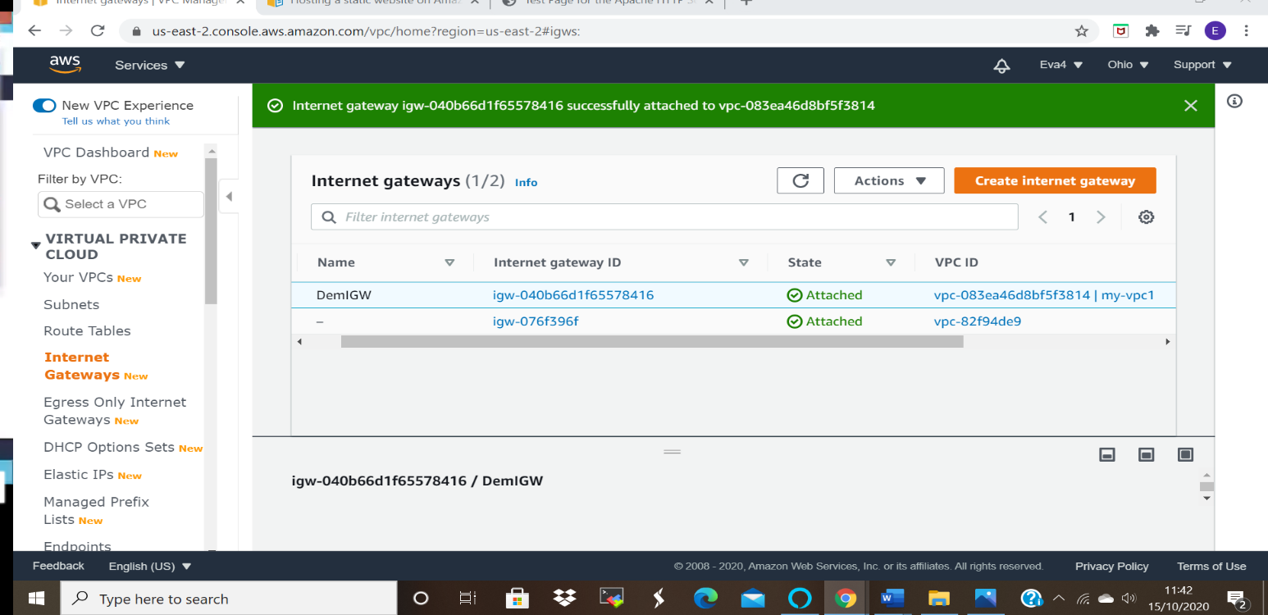

Task3: Create a route table
Ss3: Route table with routes
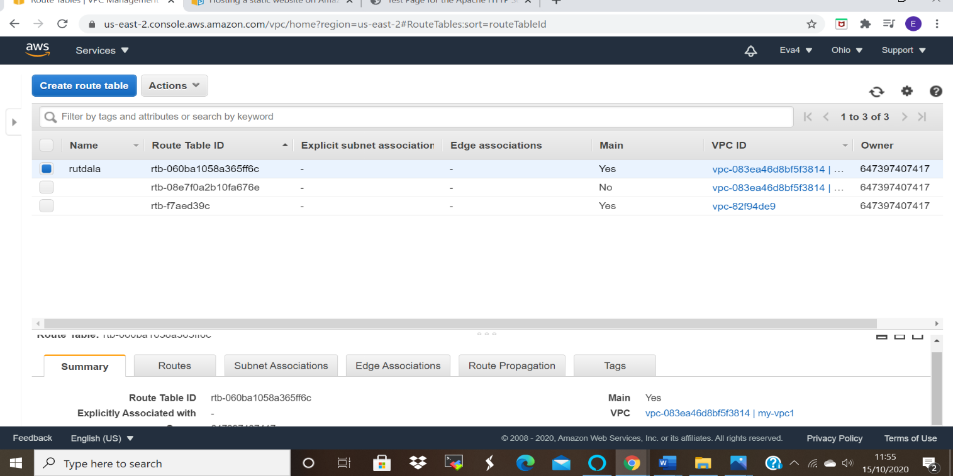

Task4: Create a subnet
Ss4: Subnet screen

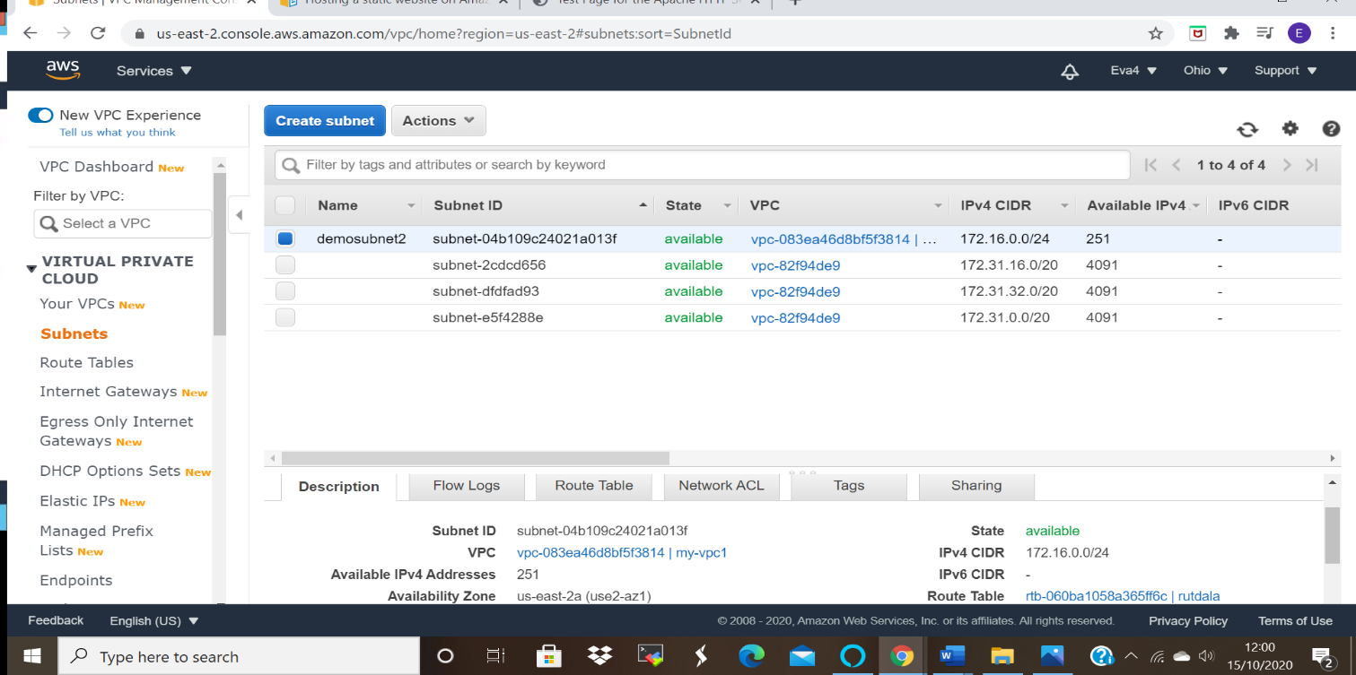

Task5: Create an EC2 in custom VPC
Ss5: Ec2 dashboard

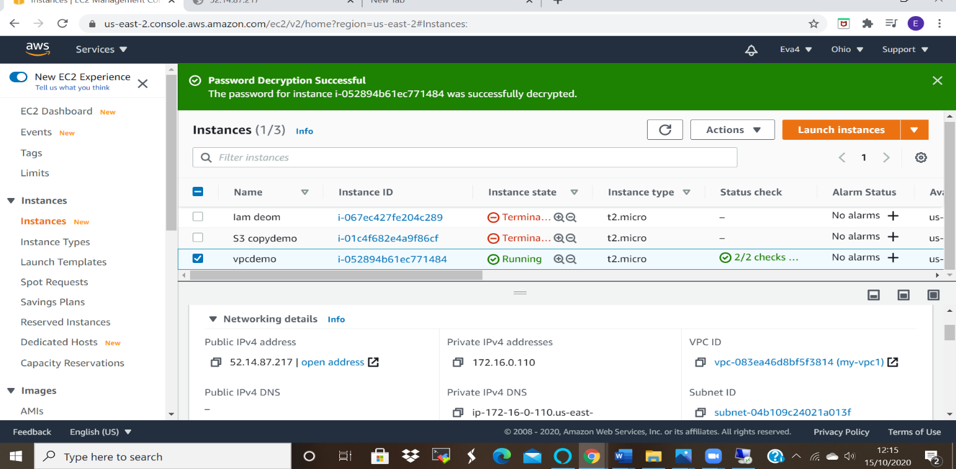
Task 6:Check ipconfig in VM command prompt.
Ss6: cmd prompt:ipconfig

